Assignment 1
  - Deadline: Day 11/03/2017 @ 23:59
[Total Points for this Assignment are 12]

Mobile Application Development
IT448

Instructions:
- This Assignment must be submitted on Blackboard via the allocated folder.
- Email submission will not be accepted.
- You are advised to make your work clear and well-presented, points may be reduced for poor presentation.
- You MUST show all your work.
- Late submission will result in ZERO points being awarded.
- Identical copy from students or other resources will result in ZERO points for all involved students.
- Convert this Assignment to PDF just before submission.
Student Details:
Name: ###  CRN: ### |  | ID: ###

Question One
2 Points
Learning Outcome(s):
Instructors: State the Learning Outcome(s) that match this question

List any two features that make mobile devices important in our daily life?
Notes: 1. Only list each feature within one line, no need to discuss or explain.
2. The question related to mobile device AND not mobile application.

Question Two
2 Points
Learning Outcome(s):
Instructors: State the Learning Outcome(s) that match this question

Draw the life cycle of Android mobile application.
Notes: 1. Caption your drawing with proper states and methods.
2. You need to do “hand” drawing ONLY. Then, take picture’s snapshot
and paste it here. See illustration example below.
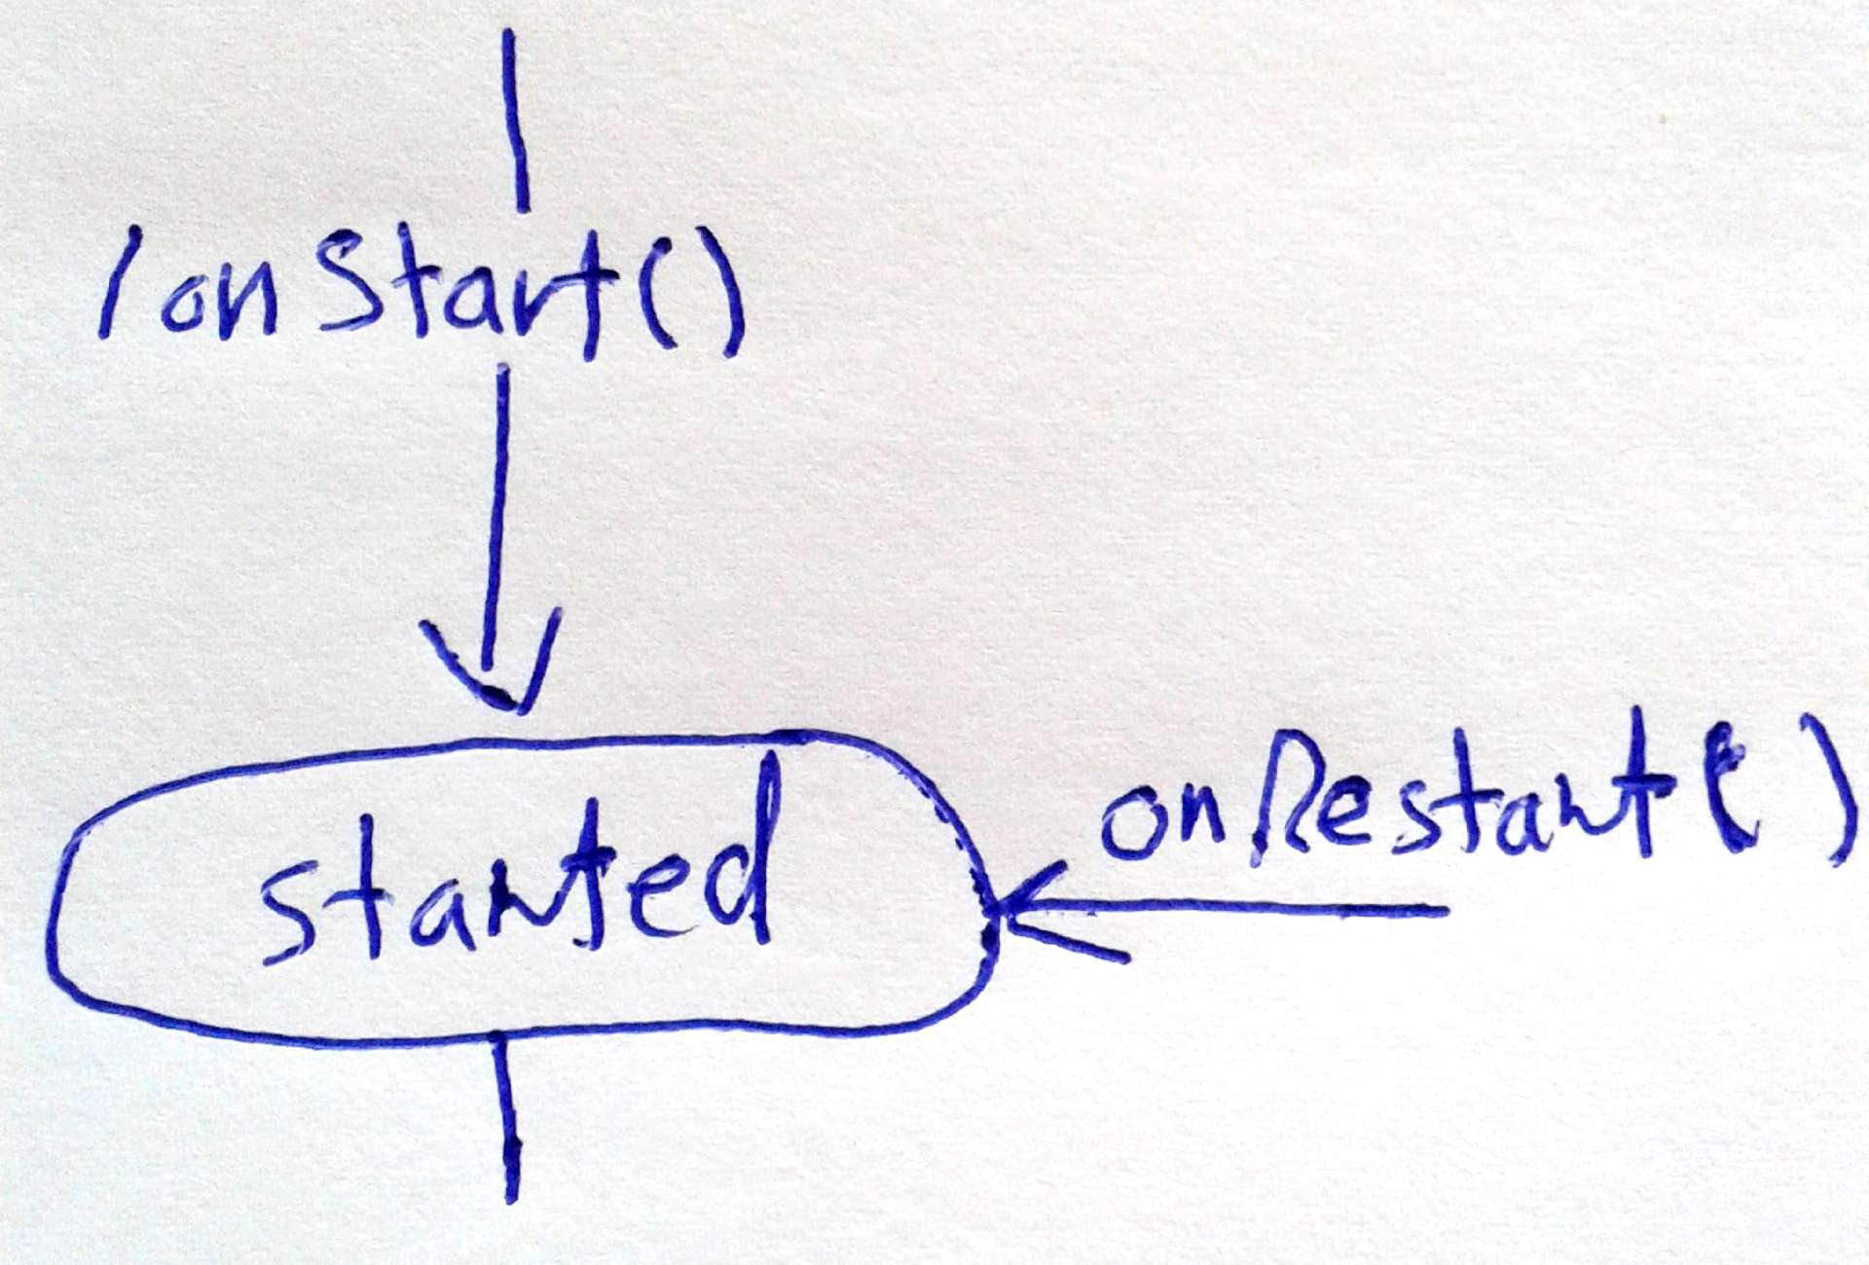

Question Three
3 Points
Learning Outcome(s):
Instructors: State the Learning Outcome(s) that match this question

List and discuss in details the Android App. Components (Main files in the app)?

Question Four
5 Points
Learning Outcome(s):
Instructors: State the Learning Outcome(s) that match this question

Suppose you are designing a login activity for your app. The app has two activity (LoginActiviy, NewActivity). Write only the Java Code here for LoginActivity. The login activity is show in the following figure:
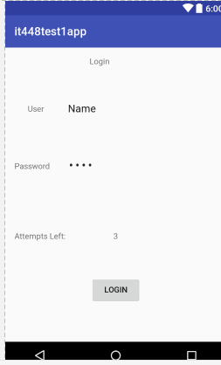
btnlogin
txtvleft
etxtpass
etxtname
The user name will be “admin” and password “admin”. The user has only 3 attempts to try to login, for each wrong trail the number of attempts left will be decremented by one. Once the attempts left is zero the login button should be disabled.
If the user enters the user name and password correctly and press login, A new activity “NewActivity” should be opened using intent.

